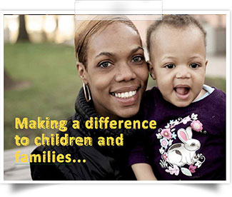

**JOIN US FOR A BRIGHTENING LIVES ACTIVITY!**

**EVENT NAME:**

**TO BENEFIT:**

**DATE:**

**TIME:**

**LOCATION:**

**ITEMS NEEDED:**

**To help children and families in need**

The Bright Horizons Foundation for Children creates Bright Spaces which are play environments in homeless shelters, domestic violence refuges and refugee centres. Bright Spaces provide vulnerable children with the opportunity to play, learn and build positive relationships, in a place of safety.

**For more information visit www.brighthorizonsfoundation.org/eu**

